**12 Best AiOps Platforms to Analyze and Monitor Data, Website, Logs, Network, and More**

By [Durga Prasad Acharya](https://geekflare.com/author/durgadell95/)

AIOps platforms leverage the latest concepts such as artificial intelligence, machine learning, and Big Data to enhance overall IT operations.

Present-day businesses deal with massive amounts of data generated from their networks, systems, and applications.

Since data is the major driver of modern businesses, if you can use data intelligently, it can help you in a million ways.

You can gain powerful insights from data to [streamline your workflow](https://geekflare.com/best-workflow-automation-and-integration-platform/), enhance IT operations, boost productivity, [increase security](https://geekflare.com/sase-data-security/), and prevent risks.

However, manual ways to aggregate, process, and manage data are highly challenging and risky.

This is where AIOps platforms can help you.

Let’s understand what AIOps is and the best AIOps platforms for your business.

**What Do You Mean by AIOps?**

Artificial Intelligence for IT Operations (AIOps) is the application of AI to automate and improve IT operations.

The term “AIOps” was coined in 2016 by Gartner, a reputed IT research and consulting firm.

AIOps leverages [Big Data](https://geekflare.com/learn-hadoop-big-data/), analytics, and AI concepts such as machine learning for several use cases, including casualty detection, anomaly detection, event correlation, and more.

AIOps is used by businesses to automatically analyze massive data volumes from devices and networks to find patterns and gain valuable insights. It helps them identify issues and causes, predict future errors, and prevent them.

This way, they can improve their IP operations and accelerate the entire process to remain ahead of the competition.

**What is an AIOps platform, and What Does it do?**

AIOps platforms are software built using the concepts of AIOps to combine Big Data, AI, and [machine learning](https://geekflare.com/learn-data-science-and-ml/) to automate, enhance, and support IT operations.

They work by ingesting and analyzing data generated by an organization’s network and systems. They enable you to use multiple data collection methods along with presentation and analytical technologies so you can gain excellent insights from data to detect issues on time while preventing future problems.

AIOps platforms perform functions like:

* **Data collection and aggregation:**AIOps begin by collecting and aggregating data from multiple sources, such as IT infrastructure applications, components, and monitoring tools.
* **Data analysis:** It involves analyzing data in real time at the ingestion point. It also includes analyzing historical data stored on your systems. This aims to identify significant patterns and events related to network and system availability issues and performance.
* **Reports and diagnosis:** After detecting the issues, AIOps platforms initiate actions immediately based on the gained insights. They can even diagnose issues without requiring human intervention. It helps address the root causes and report them to concerned IT teams for rapid response.

**How do AIOps work?**

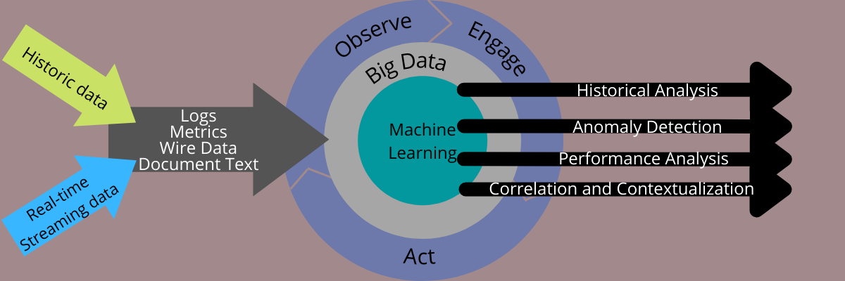

To understand AIOps’ work, let’s look at its various components and what they do.

* **Huge data volumes:** AIOps require diverse and extensive data from IT operations and services, including incidents, changes, metrics, events, and more.
* **A Big Data platform:** Since Big Data is a crucial element of AIOps, a Big Data platform brings together structured and unstructured data generated from various systems to enable analytics in real-time and for historical data.
* **Machine learning (ML):** A Big Data platform employs ML to analyze large chunks of data and automates the process with speed and accuracy.
* **Observation:** AIOps involves observing issues and metrics in aggregated data to gain powerful insights.
* Documentation: The analyzed results are documented to create a remediation plan. It also highlights compliance requirements.
* Automation: The issues are resolved using tools to automate the process quickly without errors.

The platform can also notify responsible teams of events so that they can take immediate action. In addition, AI and ML involve continuous learning to improve problem-handling capability.

**Why do businesses need AIOps?**

Businesses of all sizes need AI-driven monitoring to ensure everything works fine by detecting and resolving issues and mitigating risks. This also helps streamline operations and increases productivity and ROI.

Let’s understand how AIOps makes this happen.

**Faster Mean Time to Resolution (MTTR)**

AIOps can easily and quickly detect the root causes of issues in your systems and network and propose suitable solutions with greater accuracy than manual means.

This helps cut through IT operational noise and correlate data from several IT environments. As a result, it accelerates the meantime to resolution (average time taken to completely resolve a system failure).

**Proactive and Predictive Management**

Since AIOps keeps on learning, it improves continuously from new and previous experiences.

This makes it more capable of detecting issues and differentiating them as urgent and less urgent. In addition, it also makes the system make accurate predictions to address potential problems to mitigate risks.

**Better Productivity**

AIOps platforms provide alerts based on specific parameters to classify the severity of the risks. These alerts are also sent with complete context to help you understand the problem quickly and plan for remedies.

This enables your team to prioritize and address riskier concerns first and secure your network and systems. As a result, they can efficiently resolve issues, which increases their productivity.

**Increased ROI**

Addressing issues faster with AIOps allows you to secure your systems, networks, and data. This means you can make the most of all the systems you have enabled for AIOps, which increases your return on investment. You remain not only safe but also compliant with laws.

So, if you are looking for good options, here are some of the best AIOps platforms you can consider for your business.

**Sematext Monitoring**

Collect metrics and events across your entire stack with [Sematext Monitoring](https://sematext.com/spm/?utm_source=geekflare&utm_medium=referral&utm_campaign=listicles,%20AiOps&utm_content=infra%20lp" \t "_blank). With over 100 different integrations, you can get started in minutes and be well on your way with [alerts and anomaly detection](https://sematext.com/docs/alerts/?utm_source=geekflare&utm_medium=referral&utm_campaign=listicles,%20AiOps&utm_content=alerting%20docs) rules.

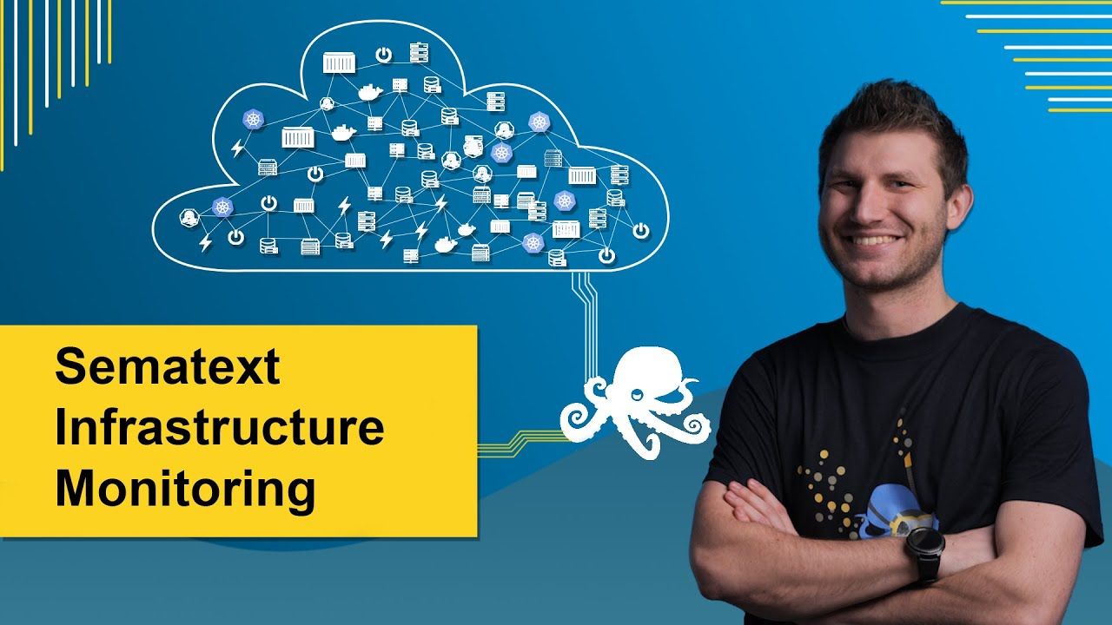

Monitor your entire infrastructure with end-to-end observability for:

* applications
* servers
* containers
* processes
* inventory
* events, etc.

Sematext is a simple yet powerful tool that takes all the guesswork out of troubleshooting. Detect production and performance issues through logs, metrics, synthetic, and even real user monitoring. Bring it all together into one single dashboard for full control.

Sematext provides monitoring tools for [DevOps](https://geekflare.com/devops-tools/) teams that want to move faster, all without sacrificing the integrity of the foundation that they’ve worked so hard to build. Map and monitor your infrastructure in real-time, and never miss a beat again.

**Dynatrace**

Simplify cloud complexity with automation, cloud-native application, AI, and observability in one platform using [Dynatrace](https://www.dynatrace.com/). It streamlines cloud operations, integrates with cloud technologies and platforms, and automates DevSecOps.

From monitoring infrastructure and applications to experiencing application security and digital advantages, Dynatrace offers the best capabilities. It can support your whole technical team with an easy-to-use platform.

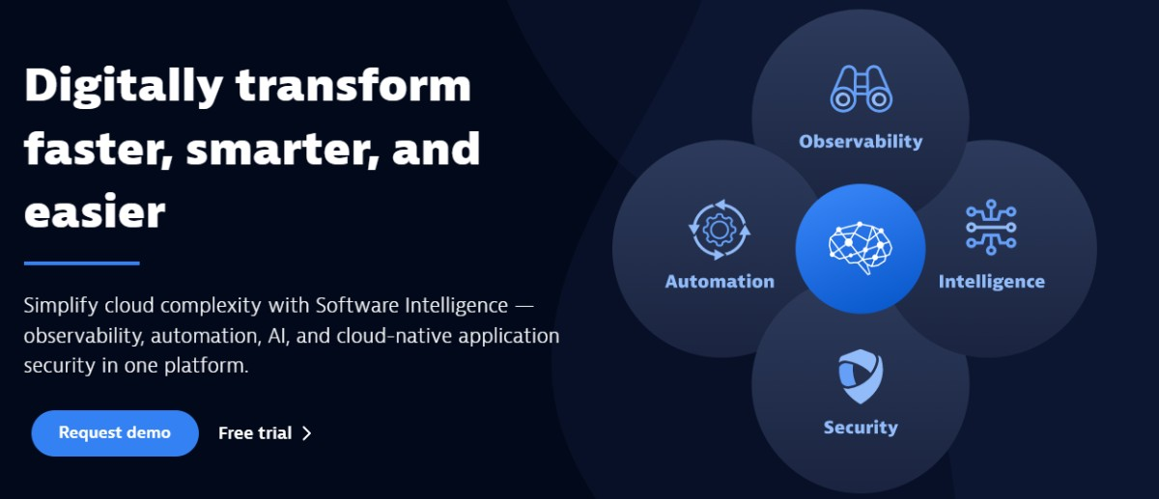

Dynatrace can work seamlessly across your full tech stack to enhance collaboration and drive your business faster. You can secure and automate DevOps pipelines to improve speed, quality, and innovation throughout the software development lifecycle.

The power of AI will resolve the predicted problems faster before they can harm your users. Boost revenue and conversions to deliver a better experience consistently to the end-users using powerful insights.

Get simple, predictable, flexible, and transparent pricing options for your needs. Connect to the Dynatrace platform for a custom and live demo. They also offer a free trial.

**AppDynamics**

Experience full-stack observability with [AppDynamics](https://www.appdynamics.com/) and go beyond monitoring. It helps prioritize the important tasks for your customers and business so that you can view, analyze and take immediate actions.

Turn your business performance into profit by understanding application and user behavior. Make informed business decisions by correlating the business performance with essential metrics, such as conversions.

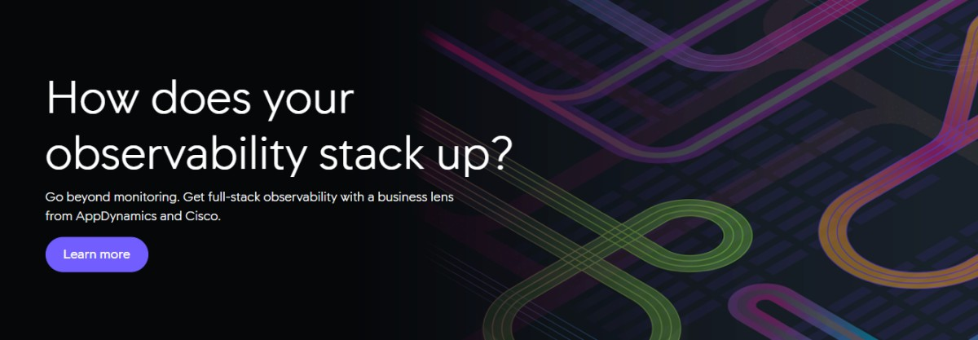

Resolve detected issues quickly before they harm your bottom line and enhance your business growth by ensuring a hassle-free and seamless experience at each touchpoint. From third-party APIs to code-level issues, spot every root cause of the problems.

Allow your IT teams to identify the application issues quickly that impact key business metrics. You can optimize your complete infrastructure from server to cloud-native environments and databases.

Check with external networks with which your applications can rely and gather effective insights to resolve application issues with any SaaS, [DNS](https://geekflare.com/dns-filtering-benefits-for-business/), ISP, or third-party provider. With better performance, security, and business insights, you can easily detect security and code vulnerabilities.

AppDynamics can solve your major business challenges with scalable, flexible, and straightforward packages and offers a free trial.

**PagerDuty**

Higher uptime is necessary for better operations, ROI, keeping the business on, and faster issue resolution. And [PagerDuty](https://www.pagerduty.com/) helps you do that. It is one of the best AIOps platforms to monitor and analyze data, logs, networks, websites, etc.

You will get an automated incident response, flexible schedules, alerting, escalations, runbook automation, event management, and operational analytics.

PagerDuty offers more than 650 integrations for your running applications, including [AWS](https://geekflare.com/aws-key-terminology/), Slack, Okta, New Relic, Zoom, etc. It keeps you at the top to tackle every problem popping up and enhances your business growth.

Furthermore, PagerDuty’s AIOps solution delivers the best noise reduction option, automation capabilities, and root cause analysis. Get the proper context and signals you need in real-time to resolve your application issues faster, reduce downtime, and improve performance.

PagerDuty can help reduce unwanted noise, understand the impact of current changes, and visualize maps for a better context. It will also allow you to gain situational awareness during troubleshooting, process events to determine the next action and resolve incidents with built-in automation through Rundeck.

With PagerDuty, you can improve team health, lower costs, bridge the gap between hybrid operating models, and enhance mobile experiences for the response.

You can get started with a free package to know how it works. A free trial is available with the paid plan starting from $21/user a month.

**Datadog**

Get modern security and monitoring with [Datadog](https://www.datadoghq.com/) to view inside the application and stack at any scale anywhere across your network. It offers everything in one place, from your servers, and clouds, to applications and teams.

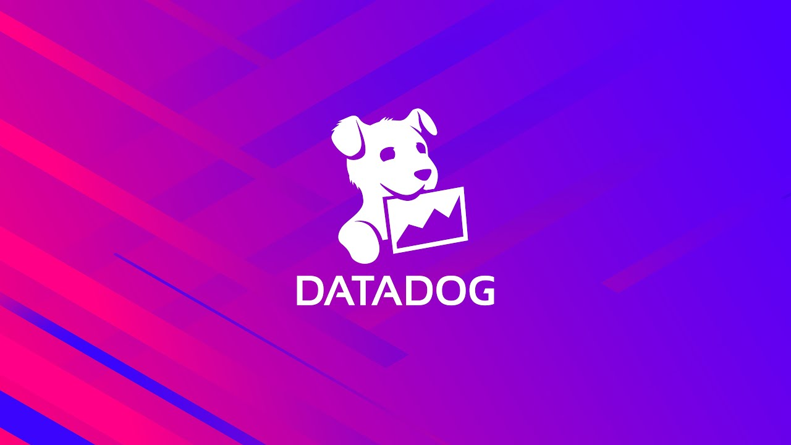

See across the services, applications, and systems. Datadog aggregates events and metrics with the help of turn-key integrations across the complete [DevOps](https://geekflare.com/devops-lifecycle/) stack.

You will get automation tools, instrumentation, monitoring, bug tracking, cloud providers, SaaS providers, common server components, listed integrations, and a lot more.

Optimize, troubleshoot, and monitor application performance by:

* Tracing requests from the distributed systems
* Tracking application performance with generated service overviews
* Getting alerts and graphs based on the error rates
* Instrumenting your code by using open-source tracking libraries.

Explore log data from various platforms, applications, and services and analyze it based on the context. Navigate between metrics, request traces, and logs and see the data with automated tagging as well as correlation.

Monitor the critical journeys of your users with an easy-to-use and simple web recorder. Save your resources with self-maintaining and AI-powered tests, manage your SLOs and SLAs easily, and receive alerts on performance issues.

Datadog offers features such as:

* Correlating the frontend performance along with the business impact
* Visualize the traffic flow in a cloud-native environment
* Interactive dashboards
* Systems metrics and events
* Alerts on application issues
* API access to add a new integration

Get a free trial option with a paid plan.

**New Relic One**

Enhance, debug, and monitor your full-stack observability with [New Relic One](https://newrelic.com/). It is one of the leading observability platforms where “Dev”, as well as “Ops” teams, work together to solve issues with data.

Get events, logs, traces, and metrics, everything in one secure cloud where you will find a dashboard, alert, and queries. In addition, collaborate and debug from your IDE and get AI assistance at each step.

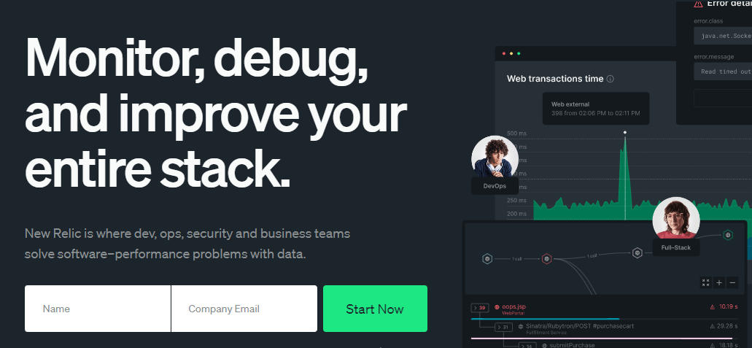

New Relic One offers visibility, flexibility, and predictability to your services along with other services it interacts with. It is the world’s robust observability platform that offers complete application visibility from backend to frontend devices.

Fix the issue faster with powerful in-depth transactions and distributed tracing details. You can also view the hidden errors without complex configuration.

Spot unusual modifications across your services, log data, and applications with instant anomaly detection. It helps reduce alerts by 90% by automatically correlating events and alerts from the sources.

Get transparent and straightforward pricing options. It’s free for 100GBs/month. For growing teams, it comes with $0.25/GB.

**Instana**

[Instana](https://www.instana.com/) helps your Dev and Ops teams shut down manual application monitoring and observability functionality. It offers fully automated full-stack observability with context to help you take smart actions and ensure better application performance.

Instana automates profiling, tracing, and monitoring all the services and applications. In addition, it automates mapping, configuration, and discovery without human configuration. Instana also allows you to monitor every service, profile every process, and trace every request.



Furthermore, Instana enables an AI-assisted troubleshooting process to understand the incidents and automates the remedy. It can trace every mobile application request and browser by correlating it with the backend applications.

Instana automatically isolates captured browser errors, such as JavaScript errors, and combines web data with end-to-end infrastructure and services. It supports all virtual, serverless, and physical services and functions and identifies the sub-optimal cloud computing workloads to resize your cloud systems.

Start your free trial today.

**LogicMonitor**

[LogicMonitor](https://www.logicmonitor.com/aiops)‘s AIOps platform allows your business to see what comes before it harms your application. Spend less time troubleshooting, and add value to your innovation by spending more time.

AIOps delivers machine learning and AI that provides meaningful alerts, enables foresight, illuminates patterns, enables automation, and provides context. Its early warning signs detect symptoms that help in solving issues.

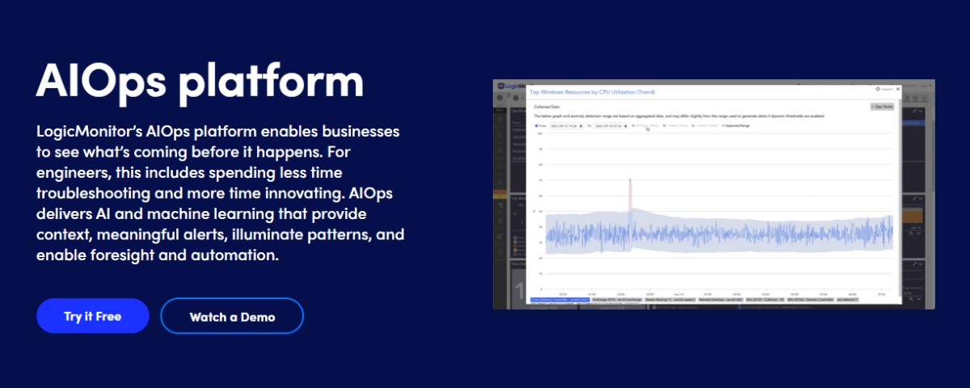

The warnings trigger actions, including custom scripts and integrations, to prevent unwanted issues from coming around. This helps prevent outages, and money, avoid negative impacts on the brands, and save time.

LogicMonitor streamlines operations with the help of AIOps and prevents issues before they occur. It also discovers correlations automatically between resources to get the source and enhance MTTR.

Use robust anomaly detection to get alerts for the problems that arise outside the operation range of the resource. LogicMonitor eliminates the manual actions for monitoring and observability to improve monitoring ROI.

Get a perfect quote or try it for free.

**Moogsoft**

Ensure the availability of your application with automated correlation, collaboration, and noise reduction across the workflow with [Moogsoft](https://www.moogsoft.com/" \t "_blank). It enables you to experience fewer downtimes and helps minimize the alert noise by 99% to focus on your business growth.

Moogsoft automatically detects the anomalies and connects the networks between the alerts to identify the root cause immediately. You will experience continuous delivery, which leads to constant changes.

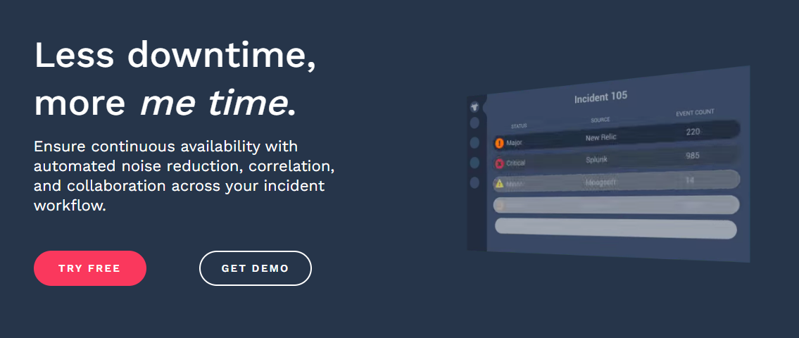

Moreover, Moogsoft improves the automated incident management workflow and saves time, letting you do essential tasks. It detects the issues early before they happen and has automated workflows for routing the incident, remediating it, and auto-closing it with the help of third-party systems.

Use Moogsoft for free and get one correlation detection, up to 5000 events, up to 500k metrics, and up to 3 user options. Take a 14-day free trial of the paid packages for unlimited users.

**Grok**

Get [Grok](https://grokstream.com/)‘s AIOps platform to simplify your infrastructure observability and monitoring. It offers an innovative approach to solving complex problems within minutes and scales according to your business needs.

You will get robust artificial intelligence and a machine learning platform to eliminate critical operational tasks, such as correlation, root cause analysis, incident prediction, and noise reduction.

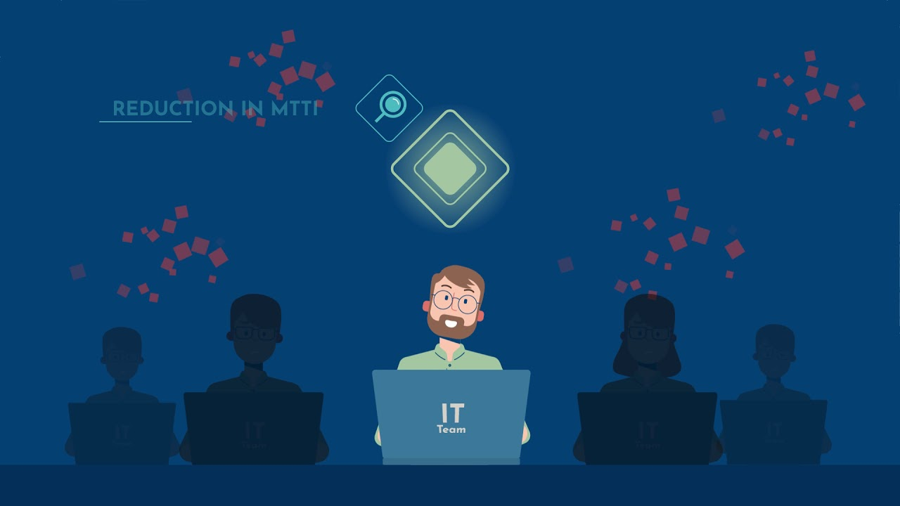

This AIOps solution lets you eliminate the effort and time on manual administrative tasks. It is built for network, IT, and infrastructure teams to make their work easy and effective. It also allows you to build your infrastructure models with patterns, signatures, and relationships.

Grok’s models learn from history and update their intelligence according to the changes in the environment. This maximizes your business benefits and minimizes the burden of resources and the cost to the organization.

Request a free demo or start using the Grok platform with the free trial option to learn how AIOps makes your IT job simpler.

**Netreo**

Automate your workflow for easy observability across the enterprise in a unified and single dashboard with [Netreo](https://www.netreo.com/" \t "_blank). It offers full-stack visibility into the IT systems, applications, user experience, and infrastructure.

Netreo’s AIOps engine provides accurate answers from data leveraged from over twenty years of trends and historical baselines. You will get real-time dashboards, extensive ITSM integration, and dynamic automation to make intelligent decisions at the right time.

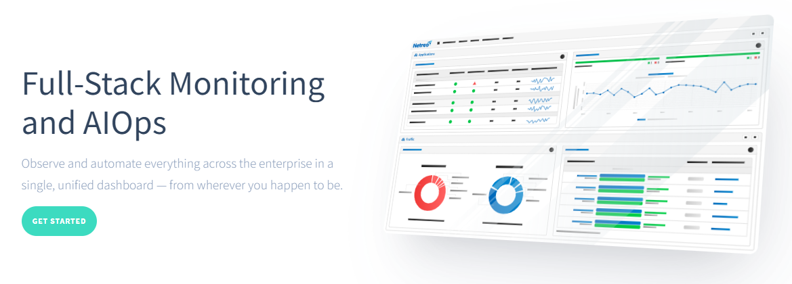

Furthermore, it can be used in healthcare centers, retail stores, banking sectors, and more. You find comprehensive global views to identify the cause of an outage. Avoid working with multiple teams on a single issue; Netreo saves your time and eliminates confusion.

Spend more time supporting engineering, attending meetings, and empowering end-users with Netreo’s AIOps platform. It builds a solid backbone of AI- and ML-based techs, including automatic dependency mapping, event correlation, anomalistic behavior detection, etc.

Get flexible and advanced monitoring solutions for your infrastructure at $6/resource/month.

**BigPanda**

[BigPanda](https://www.bigpanda.io/)‘s AIOps automation platform enables infrastructure and application observability and allows technical Ops teams to keep the economy running digitally.

With BigPanda’s AIOps platform, you can:

* Reduce your IT operations cost by 50% and more.
* Improve availability by minimizing MTTR by 40%
* Accelerate business operations and DevOps innovation.



Aggregate the complete data from all monitoring, topology, change, and observability tools. BigPanda provides Open Box Machine Learning to correlate the data into actionable insights and [detect incidents](https://geekflare.com/security-incident-response-tools/) in real time before they incident could escalate.

Identify the root cause of the issues by accelerating outage and incident resolution. With Level-O automation, you can resolve any incident faster. BigPanda also streamlines and automates the response lifecycle across incident ticketing, war room creation, notifications, and triage.

Use the self-service REST API to bring your applications to connect with teams easily and share reports accordingly.

**Conclusion**

AIOps platforms use AI, Big Data, and ML to collect and analyze data in order to detect and resolve issues faster and with more accuracy.

Thus, use any of the AIOps platforms mentioned above and streamline and improve your IT operations while [ensuring security](https://geekflare.com/best-xdr-solutions/).

* [](https://geekflare.com/author/durgadell95/)

Durga Prasad Acharya

Author

Durga Prasad Acharya is a Freelance Technical Writer who loves writing on emerging technologies, such as AI & ML, Cybersecurity, Web Hosting, SaaS, Cloud Computing, and more. Besides writing, he’s a web designer and is passionate about… [read more](https://geekflare.com/author/durgadell95/)

**AIOps Platforms**

1. [Sematext Monitoring](https://geekflare.com/best-aiops-platforms/#geekflare-toc-sematext-monitoring)
2. [Dynatrace](https://geekflare.com/best-aiops-platforms/#geekflare-toc-dynatrace)
3. [AppDynamics](https://geekflare.com/best-aiops-platforms/#geekflare-toc-appdynamics)
4. [PagerDuty](https://geekflare.com/best-aiops-platforms/#geekflare-toc-pagerduty)
5. [Datadog](https://geekflare.com/best-aiops-platforms/#geekflare-toc-datadog)
6. [New Relic One](https://geekflare.com/best-aiops-platforms/#geekflare-toc-new-relic-one)
7. [Instana](https://geekflare.com/best-aiops-platforms/#geekflare-toc-instana)
8. [LogicMonitor](https://geekflare.com/best-aiops-platforms/#geekflare-toc-logicmonitor)
9. [Moogsoft](https://geekflare.com/best-aiops-platforms/#geekflare-toc-moogsoft)
10. [Grok](https://geekflare.com/best-aiops-platforms/#geekflare-toc-grok)
11. [Netreo](https://geekflare.com/best-aiops-platforms/#geekflare-toc-netreo)
12. [BigPanda](https://geekflare.com/best-aiops-platforms/#geekflare-toc-bigpanda)